Report

Coms 319

First run the server program

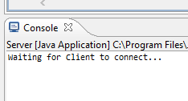

then run the client program second because the server has to be running first to be able to receive anything

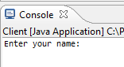

type your name, click enter, then the server will connect. I used server socket objects and commands that imports allowed me to use.

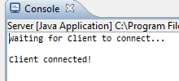

switch back to the client console and it will automatically ask you to type a message

type your message and hit enter, then it will re prompt to text again and continue running. I just used a while loop that’s always true until you terminate the program

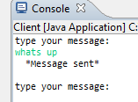

switch to the server console and it will display message and name. I used input stream and input stream readers along with buffered readers.

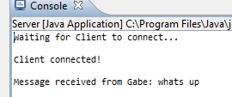

anyone connected to the server will see your messages and you can keep sending them without the program stopping

